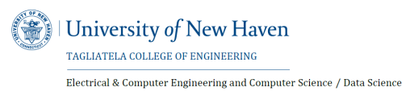

**Department: Data Science**

|  |  |
| --- | --- |
| **COURSE:** | DSCI 6007 – Distributed & Scalable Data Engineering |
| **TEAM:** | Team 12 |
| **MIDTERM PROJECT** | Due date: October 17, 2023 (midnight) |
| **PROJECT TITLE:** | Early Detection and Treatment of Severe Sepsis and Septic Shock |
| **PROJECT EXAMPLE:** | Github repo link: <https://github.com/vennelakosanam/Early-Detection-and-Treatment-of-Severe-Sepsis-and-Septic-Shock->  PitchDeck Video: <https://github.com/vennelakosanam/Early-Detection-and-Treatment-of-Severe-Sepsis-and-Septic-Shock-/blob/main/VEDIO%20DE.mp4>  PitchDeck Slides:  <https://github.com/vennelakosanam/Early-Detection-and-Treatment-of-Severe-Sepsis-and-Septic-Shock-/blob/main/sepsis%20prediction.pptx> |
| **SEMESTER:** | 2 |
| **Group Names:** | 1. Narsi Reddy Sanivarapu 2. Vennela Kosanam 3. Jagannath Patro Allupati 4. Venkata Sivannarayana Pavuluri |
| **MIDTERM INFORMATION** | Submit project: 10/17/2023 |